
Ministry of Forests
British Columbia Wildfire Service
Southeast Fire Centre

ARROW FIRE ZONE
2022

Table of Contents
Welcome to the Arrow Zone 3
Initial Attack Procedures 4
Unit Crew Procedures 4
Standby Procedures 5
Fireline Expectations 6
SEFC TYPE 3/4 Incident Commander Updates 7
Arrow Zone: Organizational Chart 8
Southeast Fire Centre Phone List 9
Zone Wildfire Coordination Officer (ZWCO) Roster…………………………………………………………………………………………………………10
Repeaters 11
Arrow Base Location 12
Nakusp Base Location 13
Trout Base Location 14
Arrow Base - General 15
Helicopter Fuel Caches 17
Orientation Tools 17

Weather Briefings 17
Ferry Schedules 18
Fire Wardens 20
Site Support Level 21
Safety 22
Notes Page 23

Welcome to the Arrow Fire Zone!

The Arrow Zone is characterized by steep mountainous terrain to the north with gentler terrain and wider valleys to the south. Located in the Interior Wet Belt, the Zone includes Interior Cedar Hemlock, Montana Spruce, Engelmann Spruce-Subalpine Fir and Alpine Tundra. There are a few small areas located along Arrow Lake and the Pend d’Oreille River classified as Interior Douglas-fir. Two mountain ranges are in the district, the Selkirk Mountains east of the Columbia River system, and the Monashee Mountains to the west. Access to the area is provided by Highway 3 from the east and west, by Highway 6, 23, and 31 from the north, and by Highway 6 and 22 from the south.

The Arrow Zone stretches from the northern end of the Arrow Lakes to the US border south of Trail, and from the height of land of the Kokanee Range in the east to the height of land of the Monashees to the west. The Zone includes the cities of Rossland, Trail, Fruitvale, Salmo, Castlegar, and Nakusp, as well as many smaller communities throughout the area. The Arrow Boundary Forest District manages several values including domestic watersheds, caribou habitat, old growth, and recreational values to name a few.

Things to be aware of within the Zone: high winds with gusts, high temperatures, low humidity, steep mountainous terrain, long travel distances, remote areas, black widow and brown recluse spiders, cougars, wood ticks, and the poison ivy plant. It is not uncommon to come across old mine shafts anywhere in the zone. Bears (black bears and grizzlies) are common throughout our region, awareness and avoidance is the most important tool in preventing bear-human conflicts. Take precautions with food and garbage and inform all personnel on the fire immediately if a bear has been sighted. Bear Spray can be obtained - ensure it is properly stored in aircraft.

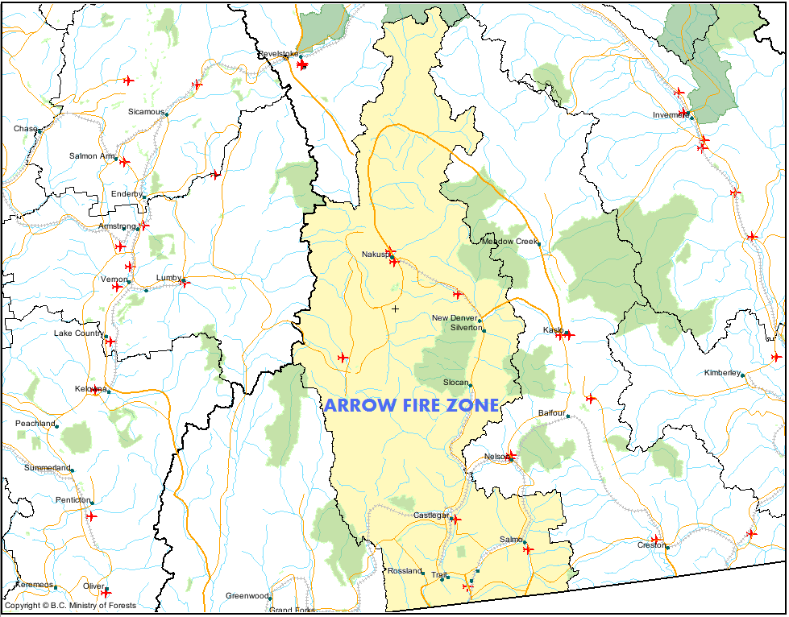
Initial Attack Procedures

- Follow all safe work procedures
- Be sure to keep the Southeast Fire Centre (SEFC) up to date regarding incident size, fire behaviour, fire status, resources on site, containment difficulties, hazards and issues, objectives and plans for current and next operational period
- Be sure to request additional resources when needed (or a Fire Officer if necessary)
- Be prepared to overnight all fires
- Be aware of skids down time and shut down hazardous activities prior to losing medical evacuation capabilities
- Local crews generally utilize webbing and carabineers to facilitate slinging operations; please request a net with your helicopter if you require one - you may be able to sign one out from the warehouse
- Always get a clear 8 hour break or seek Zone Wildfire Coordination Officer (ZWCO) for no clear 8 approval
- Final Fire reports are completed electronically via WildfireOne on the Ministry’s web page and recorded on the “P” drive – Palazzo

Unit Crew Procedures

If you are here, it is likely that we have many active fires burning and we have good potential for new fire starts and extreme fire behavior.
Please report to the Zone Wildfire Coordination Officer (ZWCO) immediately with the following info and await instruction.
- # of crews
- Medical Treatment Centre?
- # of fallers
- Gear compliment?
- Accommodations booked?
Accommodation
Crew supervisors can organize accommodation themselves.
Approved accommodation listings can be found here: http://csa.pss.gov.bc.ca/businesstravel/
The Zone Office can also assist via the Ops Assistant if time allows.

Certifications
If your crew does not have a faller, please notify the ZWCO. -Important
If your crew is not hover-exit trained, please notify the ZWCO. -Important

Aircraft Payload
It is policy in the Southeast Fire Centre to manifest total weights of crews and gear when flying.
All personnel and gear must be weighed, and total payload communicated to pilot or dispatch.
All crews flying must use aircraft payload forms (Link to Air Load Sheet).
Please take the opportunity to receive pilot/aircraft briefings before fire dispatches.
Southeast Fire Centre Standby

Alert Levels
The posted alerts indicate the maximum acceptable time period for crew mobilization, whether for dispatch to a fire or base change. Crews must confirm and understand their standby requirements with the ZWCO.

RED ALERT: Crews must be ready to depart in a helicopter within 5 minutes of a fire call.
STANDARD IA STANDBY: Crews must be wheels rolling from base within 30 minutes of a fire call.
STANDARD UC STANDBY: Crews must be ready to depart from base within 60 minutes.

Standby Hours
Hours of operation for SEFC Regional Wildfire Coordination Centre (RWCC) when alerted to standby is 08:00-16:00 locally for all Officers. One-hour lunches are expected when alerted to standby. Standby is set on Thursday and reconfirmed/uplifted Mondays.

MINIMUM STANDBY:

Officers 08:00 - 16:00 work schedule:
16:00 - 22:00 weekdays (1 hr lunch, no ETO), 09:00 - 21:00 on weekends (or as set by RWCO).

Crews 08:00 - 16:00 work schedule:
16:00 - 22:00 weekdays (1 hr lunch, no ETO), 09:00 - 21:00 on weekends (or as set by RWCO).

Crews 08:30 - 16:30 work schedule:
08:00 – 08:30 and 16:30 - 22:00 standby weekdays (1 hr lunch, no ETO), 09:00 - 21:00 on weekends (or as set by RWCO).

Additional requirements set on Monday will start 08:00 on Tuesday, and end 22:00 on Thursday.

MODIFIED STANDBY: Any hours set by the RWCO, between minimum and maximum standby (lunch standby should be considered / will be required depending on intensity level).

MAXIMUM STANDBY: 24 hours less working time.

Regional Wildfire Coordination Officer (RWCO): when activated will either be on Modified Standby (06:00 – 24:00) during shoulder season and on Maximum Standby during the core season.

Crew Rotation and Assignments
It will be up to the IA supervisor to fit you into the rotation in coordination with the ZWCO. Crews locally are on an hour balancing rotation, however, once crews have been imported, they switch to a fire rotation. Rotations may be modified due to the availability of F550 response trucks, local knowledge and availability of fallers. Your assignments will also be given to you by our local base officer.

Fireline Expectations

Point of Origin
Points of origin on suspicious fires must be preserved for investigations. Please flag off POIs and DO NOT disturb the area by any means. Do not walk in/around this area, do not drive, drag hose, or spray water in this area. This will involve controlling the fire, yet leaving the fire burning around the POI until instructed otherwise by the ZWCO.
Communication
It is preferred that Incident Commanders communicate updates/requests over the radio, to ensure everyone is kept informed. Communicating via repeater allows dispatch, ops, ZWCO, and all crews to hear updates simultaneously. Unless the repeater is tied up, please reserve the use of cell phones for long/detailed conversations.
All vehicles are equipped with SEFC repeater maps and radio instructions including local FSR frequencies. The Arrow Fire Zone operates on Tone 6. It is important to note that the Arrow Zone (especially in the north) is notorious for poor radio/repeater coverage – please ensure you have a charged SAT phone for IA dispatches.

Daily Estimated Cost (DEC) Reporting
All crews must report the required information for completing Daily Estimated Costs (DEC) to their IC.
*Submit any costs daily to ZWCO for Wildfire Costing Report.

Finance & Admin
The following forms are required if you are the IC on a fire:
- IFR - Initial Fire Report (FS260): Call into the Fire Centre on arrival at fire and updated as required.
- Electronic Final Fire Report: Digital versions with photos and scanned IC notes are to be entered on the incident drives (P Drive) and a WildfireOne fire report should be completed before departing the Zone.
- FS17 if you leave fire equipment on an incident.

It is expected that all Admin/Fire reports will be 100% completed/submitted/signed before your departure. Please use any down time to keep organized.

Resource Requesting Procedures/Expectations
Any resource requests must be relayed through the ZWCO. Factors to Consider:

- Resourcing for 4hrs to 1 Day in Advance
- Having your resources arrive before Crews
- Staging Areas / Long Term Planning
- Travel Time / Meals / Breaks for Crews / Clearing 8

Contact the ZWCO once you release any resources so they know what is currently available.

SEFC TYPE 3/4 Incident Commander Updates

Mandatory Updates to Dispatch – For entry into PRT
- Position Checks
  - “Leaving Base”, “Onsite”, “Departing Site”, “On Good Roads” etc.
  - Confirm your manifest with dispatch when departing base. Send in a quick manifest before departing if you have reconfigured your crew.
  - It is also important to advise dispatch when ON/OFF Red Alerts
- Number and Type of Resources Onsite
  - Don’t forget: First Aid Units, Security Personnel, Heavy Equipment, # of Equipment Operators, Flaggers, FD Apparatus, Industry Crews
- Quick Summary of Objectives For the Operational Period
  - E.g. “Gaining access to the fire and setting up relay tank”
  - E.g. “Establishing containment with fuel free and hose lay”
- Estimated Time of Completion & Safety Check In Requirements
  - Establish check in intervals and ETC
  - Also advise if you are overnighting so a 24 hr contact can be arranged
- Fire Size Updates
  - Specify whether it is an Estimated vs. Accurate fire size
- Fire Status and Incident Type Changes
  - Status: Out of Control, Being Held, Under Control, Out
  - Incident Type: Fire, Nuisance Fire, or Smoke Chase
Other Important Updates
- Significant Challenges or Safety Concerns
  - E.g. “Burning in steep rocky terrain, anticipate an extra day of patrol”
- Significant Increases or Decreases in Observed Fire Behaviour
  - Generally when a change in strategies and tactics takes place
- Any Referral to Medical Aid – Use of Sat Phone Preferred
- Response to all Regional Emergency Procedures will be coordinated directly through the SEFC (Medivac, Fatalities, Aircraft Emergencies, Environment Emergencies (Hazardous Spills), Interface Fires)
Resource Needs “Who to Call”
REQUEST FROM SEFC – Generally for Initial Response
- Air Tanker Requests
- RW Bucket Support for Initial Response
- HTR (Rappel Crew, Belly Tanker, Hoist Extraction)
- Fire Origin & Cause Investigator Significant Human Caused Fires
- Natural Resource Officer Compliance Issues/Suspected Industry Fires
- Mutual Aid / Agency Support:
- Fire Departments
- Utilities (Hydro, Fortis)
- RCMP
- Traffic Control
- CP/CN Rail
- Activation of Regional Emergency Procedures: Medivac, Fatalities, Aircraft Emergencies, Environment Emergencies (Hazardous Spills), Interface Fires
REQUEST FROM ZONE – Generally for ongoing support “Boots on the ground”
- Additional Crew (2nd IA Crew, Unit Crew)***
- Contract Resources (Contract Crew, Industry Faller, MTC)***
- Planned RW support (fill bladders, longline gear, crew pickup etc.)***
- Gear Orders
- Heavy Equipment / Water Tenders
- Logistics Support: Meals/Accommodations/Fuel
***These are Regional or Provincial Level Resources. Requests from the incident will go to ZWCO to ensure local prioritization. Final approval and assignment will be by SEFC OSO (Contract Personnel), RABC (Aircraft), and the RWCO (Unit Crews)
Air Tanker Requests
- State the objective: ex. “Holding action for crew to gain access”
- Values Threatened: Specific to ATR
- Updated Fire Size & Behaviour: If different from IFR
- Hazards: Powerlines, Visibility (smoke), Terrain, Unidentified Air Traffic
- Avoid information around strategies and tactics: “blanketing or boxing fires”, this can be discussed with the AAO upon arrival

Arrow Zone: Organizational Chart
Southeast Fire Centre Phone List
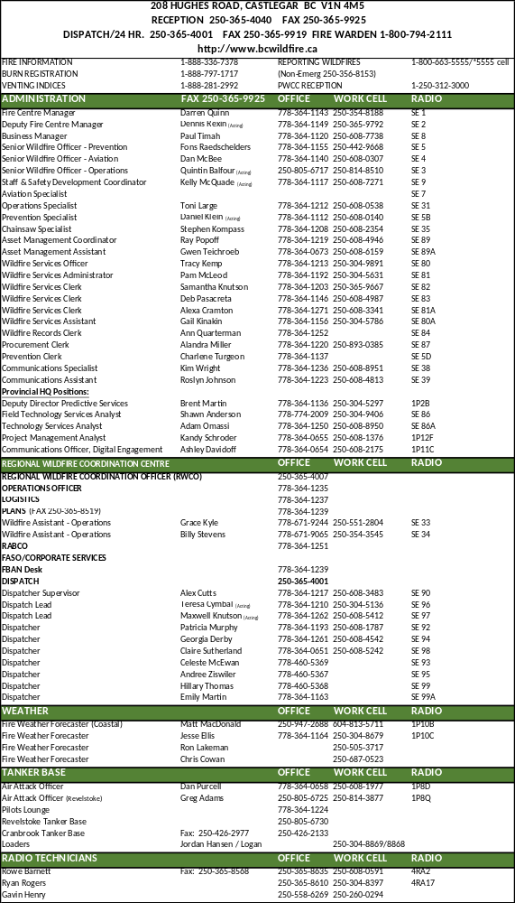

Zone Wildfire Coordination Officer (ZWCO) Roster

DATES |  | ARROW | Contact | Alternate Contact
From | To | ZWCO
21-Apr | 27-Apr | J.Hall | 778-364-1107 | 250-365-9797
28-Apr | 04-May | Carter | 778-364-1107 | 250-365-9308
05-May | 11-May | King | 778-364-1107 | 250-608-1551
12-May | 18-May | J.Hall | 778-364-1107 | 250-365-9797
19-May | 25-May | Fox | 778-364-1107 | 250-608-2450
26-May | 01-Jun | J.Hall | 778-364-1107 | 250-365-9797
02-Jun | 08-Jun | Carter | 778-364-1107 | 250-365-9308
09-Jun | 15-Jun | Richardson | 778-364-1107 | 250-608-2178
16-Jun | 22-Jun | Phelps | 778-364-1107 | 250-608-1372
23-Jun | 29-Jun | J.Hall | 778-364-1107 | 250-365-9797
30-Jun | 06-Jul | Richardson | 778-364-1107 | 250-608-2178
07-Jul | 13-Jul | Fox | 778-364-1107 | 250-608-2450
14-Jul | 20-Jul | King | 778-364-1107 | 250-608-1551
21-Jul | 27-Jul | Richardson | 778-364-1107 | 250-608-2178
28-Jul | 03-Aug | Carter | 778-364-1107 | 250-365-9308
04-Aug | 10-Aug | King | 778-364-1107 | 250-608-1551
11-Aug | 17-Aug | Richardson | 778-364-1107 | 250-608-2178
18-Aug | 24-Aug | Carter | 778-364-1107 | 250-365-9308
25-Aug | 31-Aug | Phelps | 778-364-1107 | 250-608-1372
01-Sep | 07-Sep | Carter | 778-364-1107 | 250-365-9308
08-Sep | 14-Sep | Phelps | 778-364-1107 | 250-608-1372
15-Sep | 21-Sep | R.Hall | 778-364-1107 | 250-304-5079
22-Sep | 28-Sep | J.Hall | 778-364-1107 | 250-365-9797
29-Sep | 05-Oct | Carter | 778-364-1107 | 250-365-9308
06-Oct | 12-Oct | Phelps | 778-364-1107 | 250-608-1372
13-Oct | 19-Oct | R.Hall | 778-364-1107 | 250-304-5079
20-Oct | 26-Oct | King | 778-364-1107 | 250-608-1551
21-Apr | 27-Apr | J.Hall | 778-364-1107 | 250-365-9797
28-Apr | 04-May | Carter | 778-364-1107 | 250-365-9308

Repeaters
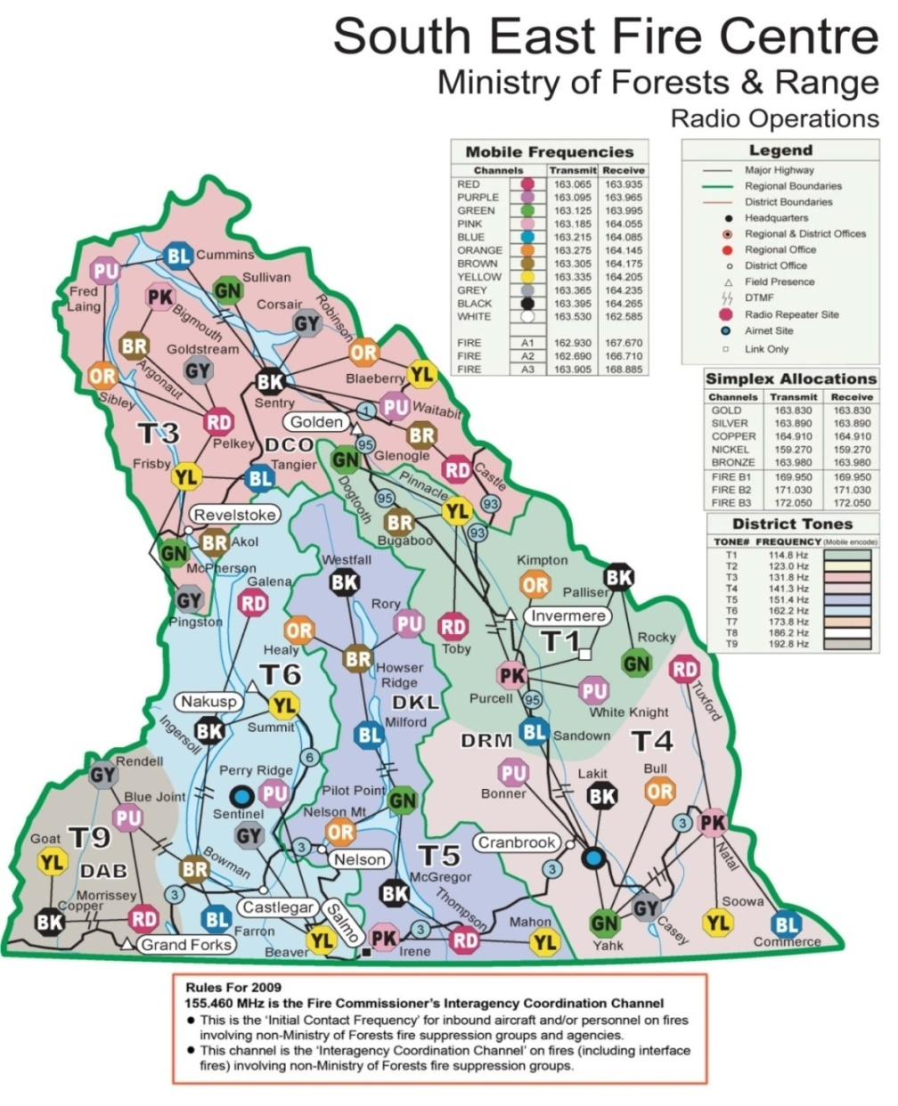
Arrow Base Location

Physical Location: Arrow Fire Zone
2501 Udell Road, Shoreacres, BC

Mailing: Arrow Fire Zone – Wildfire Management Branch
2501 Udell Road, Castlegar BC, V1N 4P5

Zone Phone: 778-364-1100
Fax: 250-359-7909

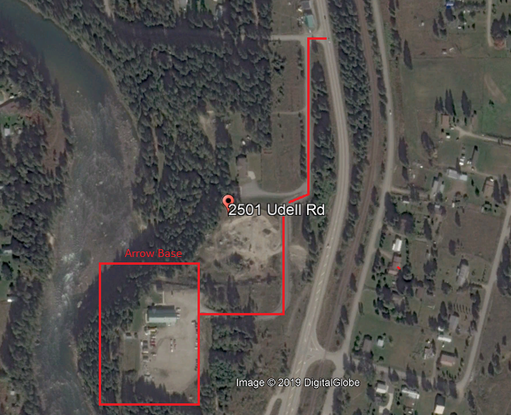
Nakusp Base Location

Physical Location: Nakusp Base (Arrow Zone - North)
2100 Hot Springs Rd., Nakusp BC

Mailing: Nakusp Fire Base – Wildfire Management Branch
Box 272, 2100 Hotsprings Road, Nakusp BC, V0G 1R0

Base Phone: 250-265-3754
Fax: 250-265-3753

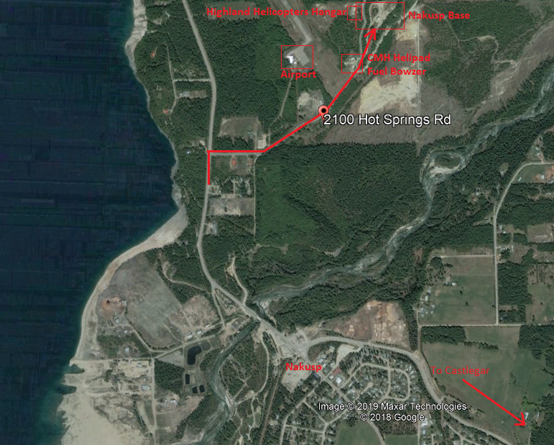

Trout Lake Base Location

Physical Location: Trout Lake Base (Arrow Zone - North)
505 Lardeau St

Mailing: Trout Lake Base – Wildfire Management Branch
505 Lardeau St, Lardeau BC

ZWCO Phone: 778-364-1107

Helipad : Ask ZWCO for combination

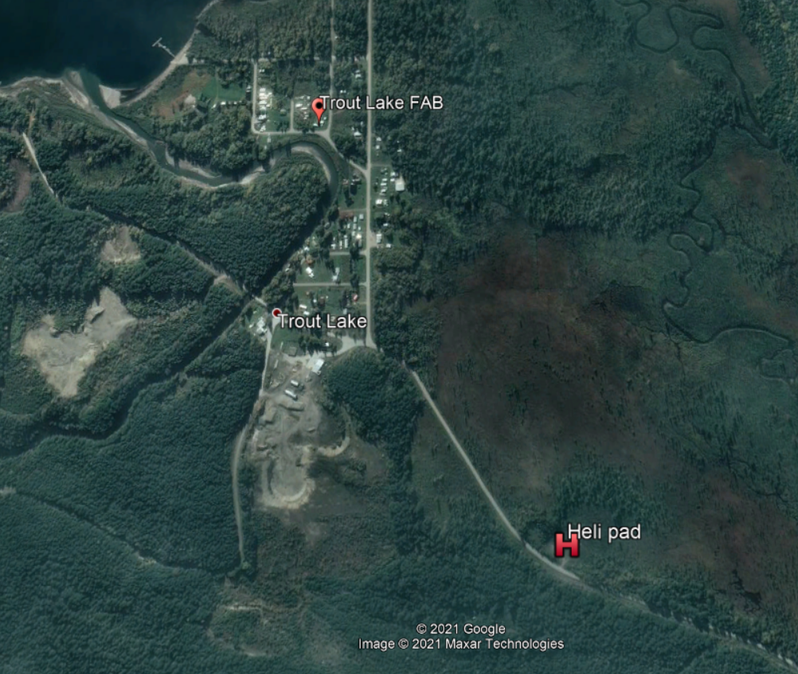

Arrow Base - General

Parking
Please refer to signs in the Arrow Zone parking lot for the following directions on where to park your vehicle:
- Visitors are to park in the main parking lot along the north fence
- Fire crew personal vehicles are parked along the east and south perimeter of the main parking lot
- Officer work trucks backed up along the east warehouse wall
- Unit Crew work trucks are parked in the centre of the main lot
- IA Crew F550s are backed up to the Sea Cans, along the west side of the main lot

Keys & Key Codes
There are different keys depending on which location within the Zone you are at. Contact the Zone Officer or local crew in your area to be assigned a set of keys. Please call the Zone Wildfire Coordinating Officer (ZWCO) if you need access to our facilities after hours if keys are not issued to you. “3303” key is used for fuel caches.

Lock Up Procedures
In the event that you are the last to leave the base, please ensure all doors and gates are locked at night or when base is unattended. Please get briefed on current alarm codes in order to activate alarm when leaving.

Gates
There are a few areas throughout Arrow Zone that require gate access - please contact the ZWCO to direct you to the necessary keys.

Warehouse & Gear
You will need to get permission from the local ZWCO before removing anything from the warehouses.
- An FS17 will be filled out when signing out or returning equipment
- An FS17 will be required when you are leaving equipment in another zone or receive equipment from another zone

The Zone Asset Management Assistant, Warehouse Person or authorized zone staff member will enter this information into IMIS. If you require special equipment or we do not have certain items that you need to do your job, please ask the ZWCO and we will do our best to get it for you.

Fuel
Please note that the Arrow Zone covers large areas of backcountry and remote areas. Ensure you have adequate amounts of fuel and be aware of gas station locations and hours of operation (they may be limited).

Fuel Shed
The fuel caches can be accessed with either a 3303 key or through the zone. Please use an FS17 when signing out gear and update the Zone Response Officer with what has been removed so it can be re-stocked. When crews deplete mixed fuels, they should replenish when possible.

First Aid Room
All first aid supplies are located in the First Aid Room, which is situated beside the Warehouse. Please report any emergencies or incidents to the ZWCO or call 911.

Washrooms & Laundry
Facilities are located at the lower level of the Arrow Zone office, between the Warehouse and the Crew Rooms. Please keep all facilities clean, tidy, and stocked.

Local drive information available (IDIR access)
If you require access to our local G:\drive, please do not move or delete any items. For system help, contact nrsenquiries@gov.bc.ca or phone 1-866-660-0811.

Folders of note:
- G:\!Publish\Fire-Operations\Plans\Manifests
- G:\!Publish\Zones\Arrow\Common Files\SOP & SOG's
- G:\!Publish\PreOrg\N5 Arrow\Zone Briefing Packages\Zone Briefing Package

Wifi Networks
BCNGN- Log in using your IDIR account and password
DOGWOOD- No password, guest access
NAKUSP WIFI- W1ldfire2020

Printers
To print a document, you can use the following printers located in our office:
- Arrow Primary Attack Base (Zone Office) Upper Floor: HPLaserjet 700 Color MFP M775Z \\fireline\P11027
- Arrow Primary Attack Base (Zone Office) Lower Floor – Crews – HP Laserjet M525f
- \\fireline\P11227
- Nakusp Base: HP 4100

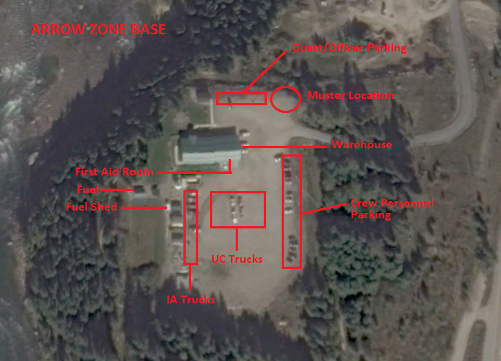

Helicopter Fuel Caches

LOCATION | LAT |  | LONG
TROUT LAKE (Helipad Only) | 50 | 39.370 | 117 | 32.97
CMH GALENA | 50 | 39.842 | 117 | 23.60
YCG CASTLEGAR | 49 | 17.680 | -117 | 38.050
YYZ TRAIL | 49 | 03.330 | -117 | 36.500
CAQ5 NAKUSP (Call ahead: 250-265-3689) | 50 | 15.735 | -117 | 48.565

Orientation Tools (Maps, GPS setup and Declination)

Please ensure you have a West Kootenay Backroads Mapbook to orient yourselves to the zone. If you are not provided with a Backroads Map, they can be purchased at local visitor centres. In addition, use the QR code below to download the georeferenced BC Provincial Repeater Map to Avenza. Avenza is a tool to download maps for offline use, and is available on the App store.

GPS Garmin Legend Setup
Time: 24 hour, Pacific Time Zone
Display: 15 seconds Interface: Garmin
Units: hddd mm.mmm’ NAD83: Metric, Meters, mmin
Headings: Degrees, True System: Normal, WAAS Enabled

Calculated Magnetic Declination for Castlegar, BC
Year: 2018 | Latitude: 49° 19' North | Longitude: 117° 40' West
Calculated magnetic declination: 14° 46' East

Weather Briefings

Southeast Fire Centre weather briefing calls are on Monday and Thursday at 9:15am.
Dial 1-877-341-9184, Conf ID #3416969

To view the region’s most recent weather briefing:
https://bcfireweatherp1.nrs.gov.bc.ca/scripts/menu/BC/ShowPage.asp?page=wxbrief

A complete list and description of SEFC weather stations can be found at: https://www2.gov.bc.ca/gov/content/safety/wildfire-status/wildfire-situation/fire-weather

Ferry Considerations

Crews may be required to cross ferries within the region. Standard TDG requirements exclude “Emergency Vehicles” when actively engaged in responding to an emergency. Emergency vehicles will get priority boarding when responding to an emergency. If it is not an emergency, there are jerry can limits for each vehicle. If Emergency Crews are traveling, please notify the ferries so they can be ready to assist - these cell numbers can be used for after hour emergency calls: 778-206-5000 (John) or 778-206-8008 (Marinus).

Needles Cable Ferry
ROUTE: Across Lower Arrow Lake, about 59 km south of Nakusp on Hwy 6, between Fauquier and Needles
DAILY SCHEDULE:
Every 30 minutes on the hour and half hour from Fauquier 5:00 am – 10:00 pm
Every 30 minutes at 15 and 45 minutes past the hour from Needles 5:15 am – 9:45pm
On-demand service 10:00 pm - 5:00 am
CROSSING TIME: 5 minutes

Upper Arrow Lakes Ferry – Galena Bay & Shelter Bay
ROUTE: Across Upper Arrow Lake, 49 km south of Revelstoke on Hwy 23 between Shelter Bay and Galena Bay
DAILY SCHEDULE:
Sails from Shelter Bay every hour on the hour starting at 5:00 am – 12:00 am
Sails from Galena Bay 5:30 am – 12:30 am
Dangerous cargo sailings are Tuesday and Thursday from Shelter Bay at 9:00 am and 2:00 pm and from Galena Bay at 9:30 am and 2:30 pm
CROSSING TIME: 20 minutes

Arrow Park Ferry
ROUTE: Across the junction of Upper and Lower Arrow Lakes at Arrow Park, 22km south of Nakusp on Hwy 6
DAILY SCHEDULE: On demand 5:00 am - 12:05 pm & 2:15 pm - 9:20 pm
CROSSING TIME: 5 minutes

Glade Ferry
ROUTE: Across the Kootenay River on Highway 3A (22.5 kilometres west of Nelson) to Glade
DAILY SCHEDULE: On demand 5:00 am – 2:20 am
CROSSING TIME: 3 minutes

CONTACT INFORMATION:
WaterBridge Ferries Inc.
Phone: 250-265-2105
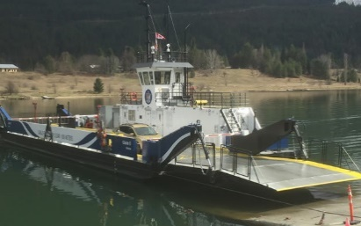
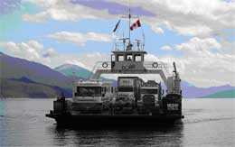
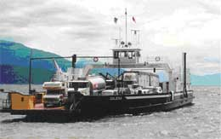
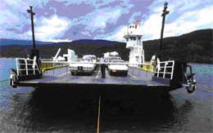

Ferry Map
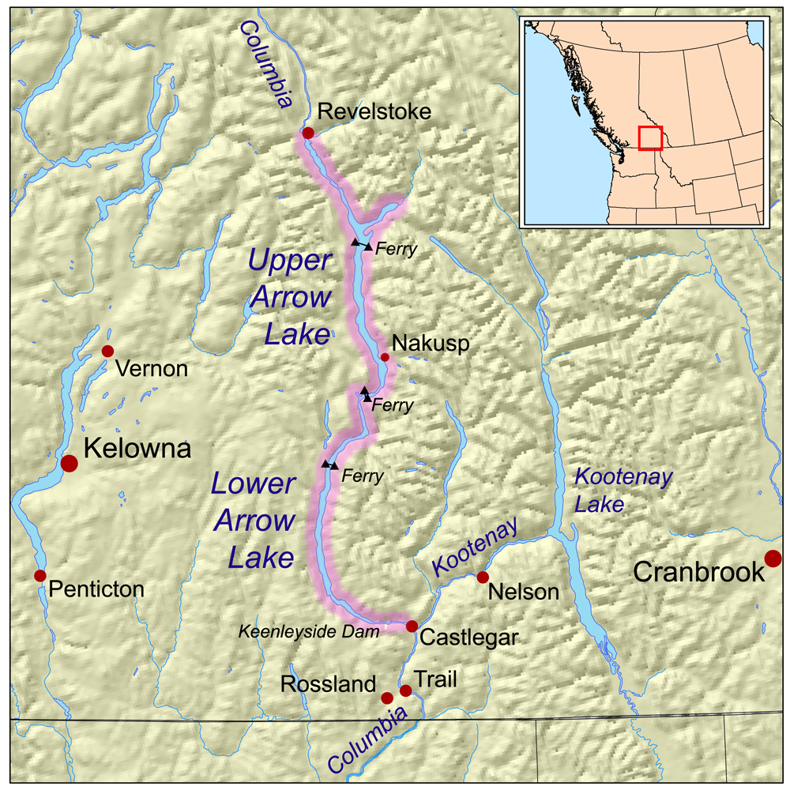
Glade
Ferry
Upper Arrow Lakes
Arrow Park
Needles

Fire Wardens

Arrow Fire Wardens | Call Signs | Location | Zone | Home Phone | Cell Phone
Paul Maika | 50B | Slocan/ New Denver | C + E | 778-206-0309
Gord Hogaboam | 50G | Nakusp / Edgewood | B + D | 250-265-4286
Bill Regner | 50H | Trout Lake / Edgewood | A + D | 250-265-3058 | 250-265-1954
Vacant | 50M | Robson / Deer Park | G + Boat
Murney Luchka | 50N | Rossland / Salmo | H + I | 250-362-5526 | 250-231-4749
Roly Worsfold | 50W | Rossland / Salmo | H + I | 250-362-5960 | 250-231-3244

Arrow Fire Zone Fire Patrol Route
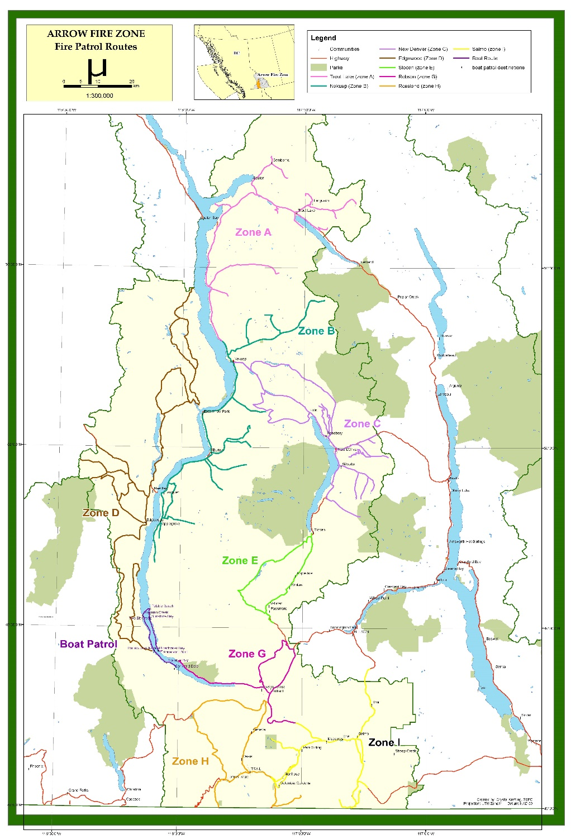

Site Support Level

MZOC – Ministry Zone Operations Centre
MFLNRO’s site support EOCDOC primarily for wildfire response operated by Wildfire Management Branch. An MZOC is activated as required for a specific geographic area with authority from RWCC. There would be 3 levels of MZOCs that may be activated depending on need and role: Type 3 expanded logistics support; Type 2 coordination and assignment of specific resources and/or specific functions; Type 1 full coordination, dispatch and use of assigned resources operating similarly to the RWCC but continuing to report to the RWCC.

ZONE - MZOC III – (normal fire operations)
All fire activity will be directed by SEFC Fire Operations. Local Fire Zone is responsible for zone level logistical support. The Zones may require specific updates depending on conditions. Your Zone contact will brief you on your role.

ZONE - MZOC I or II (increased fire activity)
This level must be initiated by the FCO and a signed MZOC Delegation of Authority letter given to the MZOC Director.

WCO - Wildfire Coordination Officer has a mandate to act in anticipation of fire problems as well as to coordinate all fire control resources at their disposal within their jurisdiction.

RWCO - Regional Wildfire Coordination Officer sets fire control priorities within the centre, controls the tactical deployment of fire control resources to the zones, including any uncommitted resources within the centre, deploys IA resources on a priority basis to specific fires.

PWCO - Provincial Wildfire Coordination Officer will assign crews to various locations within the Province. Once assigned to a particular centre, crews come under the command of the Fire Centre. When working specific fires, crews will retain contact with a Fire Centre who will keep them advised as to their specific duties and targets. The Incident Commander has control over resources assigned to a specific fire.

ZWCO - Zone Wildfire Coordination Officer (Previously called BFO, FRO, MZOC Dir., First out, Base Officer)
A person performing the duties of a ZWCO must be dedicated to this position at MZOC level type 1, 2. This should be clearly documented in the MZOC level authority granted by the RWCO. A person performing the duties of a ZWCO would not normally be dedicated to this position at the MZOC level type 4 and would not normally be required to be dedicated to this position at the level type 3 but could be based on workload and in discussion with the RWCO. A person performing the duties of a ZWCO at MZOC level type 4 and type 3 may also be identified as a RO.

RO - Response Officer (Previously called First Up, First Out, Fire Officer, On Call, IC)
Single resource identified and ready to be dispatched to a local area to respond to an incident. This person would usually be a Wildfire Officer, Wildfire Technician, Wildfire Assistant but may be a Senior Wildfire Officer, Wildfire Crew Supervisor, or Wildfire Crew Leader. The person may also be a qualified TEAM staff member or a temporary employee who may be suitable for the role. The RO may or may not become the IC but could be involved in wildfire cause & determination investigations, wildfire prioritization or other functions in support of wildfire activities. The experience level of the RO would be commensurate with the anticipated wildfire load and behaviour. The preparedness plan would dictate the number of individuals required.

ICS structure implemented on site as required.

Safety

Everyone is responsible for:
- Safety on the incident
- Personal safety and safety of others
- Reporting unsafe conditions

In this zone advisories are broadcast over the radio repeater if you are out in the field. If you have concerns about your safety, whether with aircraft, fireline activities, animals or industrial operations, please inform your supervisor in order to relay the information to the Zone Officer or Safety Officer.

Vehicle Safety
Staff involved in, or arriving at the scene of an accident should proceed as follows:

Accident Response – Basic Rules
- Code 10-50 means you have been dispatched to a potential accident scene. Aircraft may or may not be involved. You are to assume that all persons involved are alive, injured and burned.
- Code 10-45 may be transmitted to confirm death or fatality.
- Protect yourself and your passengers from undue trauma. Ensure your efforts will not endanger yourself or others.
- Protect accident areas with emergency warning devices (flags, flares, signaling, etc.).
- Provide assistance to injured victims within the scope of your knowledge or expertise in first aid.
- Call or radio the Southeast Fire Centre and notify dispatch or the receptionist of the situation. Do not mention names of any accident victims over the radio.
- Request ambulance and police as situation dictates.
- Remain at the scene until Police and Ambulance arrive.
- Provide assistance to the authorities and leave when permitted to do so.
- Advise the office when you leave the scene.
In the event of a critical incident call 1-800-661-CISM (2476)

Travelling on Logging Roads
Personnel operating vehicles on logging roads must have their vehicle equipped with a mobile radio programmed with the required logging channels for the area in which they are operating.
For safety purposes the vehicle mobile must be used for km checks - handheld portable radios must not be used for in-vehicle road channel communications on logging roads. Resource Roads should be programmed in your radios and posted at road entrances.
- Always drive according to conditions, particularly hazardous ones such as dust, snow, soft sub grade, rain storms, or areas of high non-radio assisted traffic and always adhere to speed zones.
- Expect and prepare for the unexpected – road conditions can change without warning. Drive defensively.
- Heading up call even kilometers.
- Heading down call odd kilometers.

Commercial Vehicle Safety and Enforcement (CVSE)
All commercial vehicles with a licensed GVW exceeding 5,500 kg are required to report to CVSE inspection stations (if open). There is a station located at 310 Highway 3 in Castlegar that has random operational hours. In a non-emergency situation, you are required to stop at the scales.
Notes

